|  |  |  |  |  |
| --- | --- | --- | --- | --- |
|  | **Test Method** | **Test Description** | **Expect results** | **Outcome** |
| 1 | Functionality | As a user of the QEtodolist application I want to be able to deploy this application to docker.  Steps:   1. Install Docker for windows or mac depending on op-system. 2. Open power shell or git bash in your docker folder and run a command “docker build -t qe-todolist .” 3. When the user is on the command line run “docker run -p 8081:8080 -d qe-todolist” | Results:   1. Docker will be downloaded to your PC, refer to download folders. Open the docker app and follow instructions for successful installation. 2. Docker program will build your image(site). 3. A docker image will run with your site “http://localhost:8081” | Pass – refer to image on test 1 |
| 2 | Functionality | As a user of QEtodolist I want the application to be viewed by multiple users.  Steps:  Using jmeter to stress test the application | Results:  Create thread groups and loop the users, on jmeter you can specify the number of users to land on that page. | pass |
| 3 | Functionality | As a user of QEtodolist I want the application to be viewed by multiple Browsers.  Steps:   1. Open the browser in google chrome. 2. Open the browser in FireFox. 3. Open the browser in IE. | Results:   1. Browser must display. 2. Browser must display. 3. Brower must display. | pass |
| 4 | Functionality | As a user of QEtodolist I want the application to be viewed by multiple platforms.  Steps:   1. The tool should be able to open as web application. 2. The tool can run on a mobile application. (if in scope) | Results:   1. The application must run as web application on any browser. 2. The application must run on IOS and android mobile. (if in scope) | tbc |
| 5 | Functionality | As a user when I refresh or my browser times out, I want my list to save or persist after its been refreshed or times out.  Steps:   1. Add data to the list then close the browser or f5 refresh. | 1. The browser will close but, when the user opens the browser again, their data will still be available. | pass |
| 6 | Functionality | As a user I want to be able to add items to my todolist.  Steps:   1. Add text to “Create new todo item” then click submit. | Results:   1. Once the text is added then click submit it will create a new item for you on the list. | pass |
| 7 | Functionality | As a user I want to be able to delete items from my todolist.  Steps:   1. When on the list refer to your items, there will be a X this is the delete function. | 1. The delete function will occur when clicking on the X infront of the bullet point. Your item will be deleted forever. | pass |
| 8. | Functionality | As a user I want to be able to edit items on my todolist.  Steps:   1. When creating an item add the details in the text box next to the item and click update | 1. This update but edit the item, or the user can replace the item entirely. | Fail: the user is unable to edit the item, the update erases the entire item. Does not show a option to edit the text. |
|  |  |  |  |  |

Test 1

Test 2

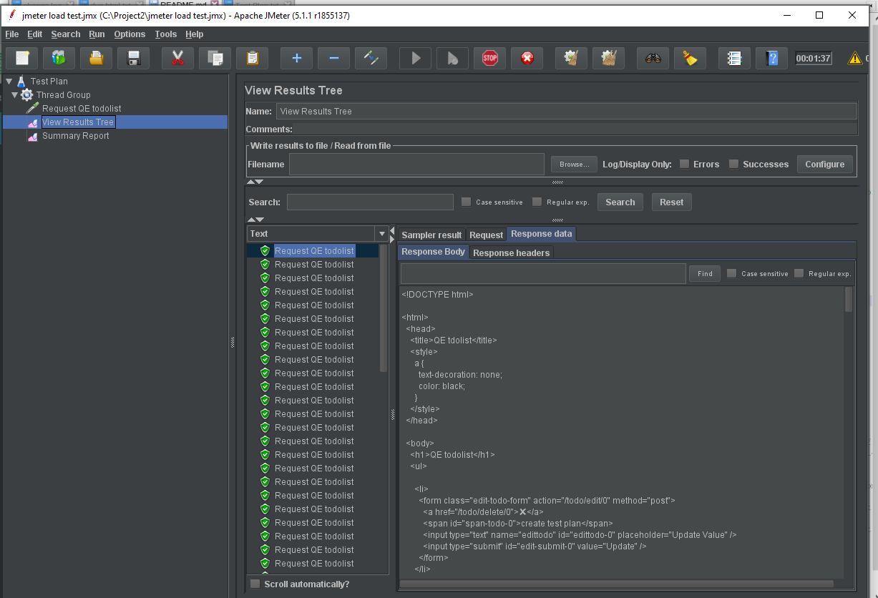

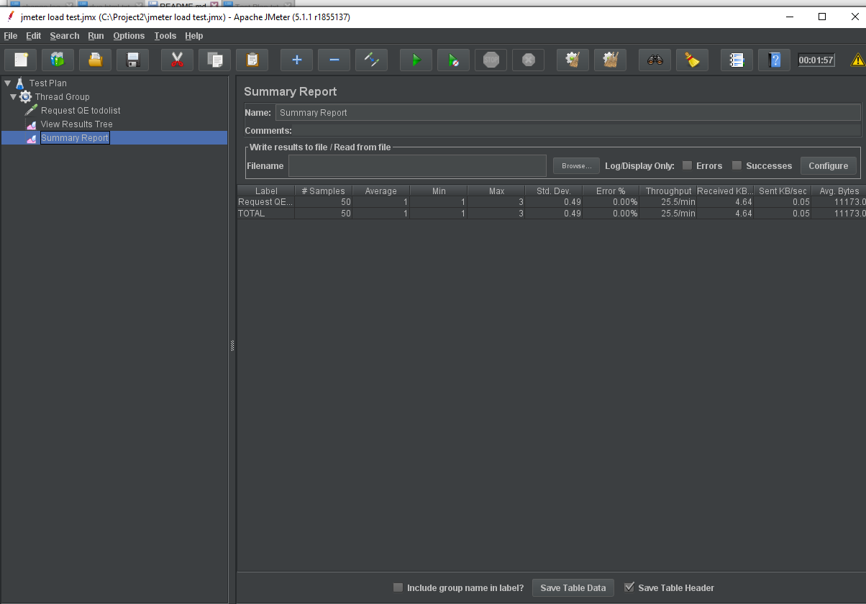

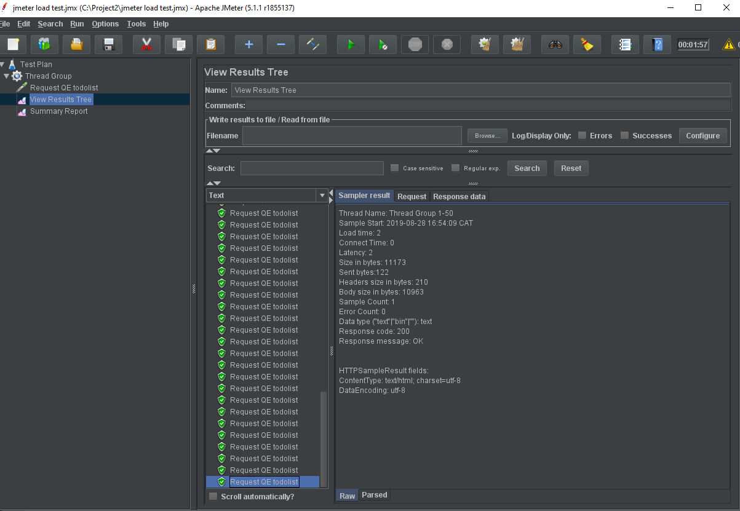

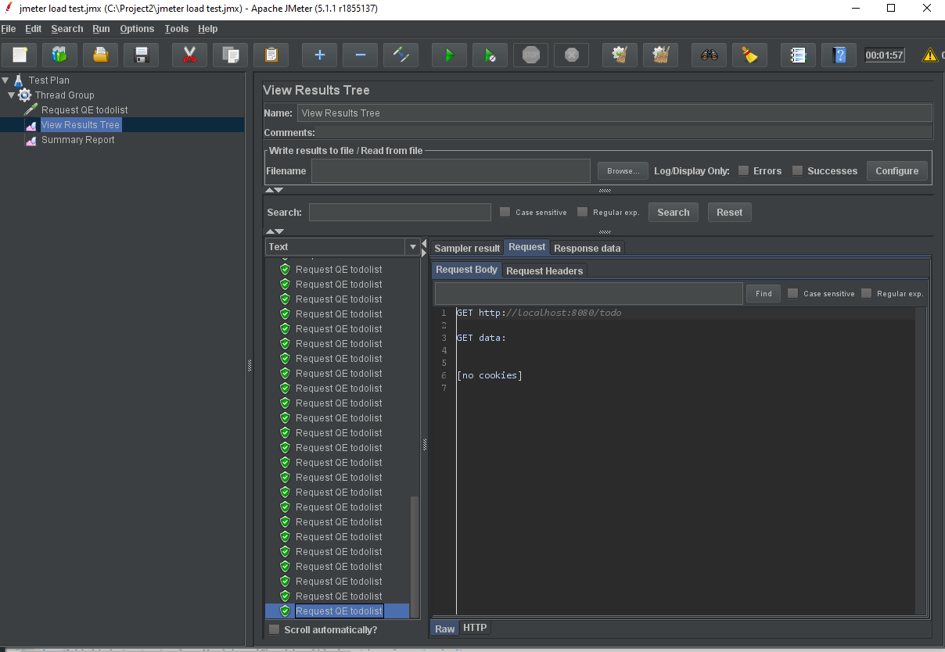

Test 3

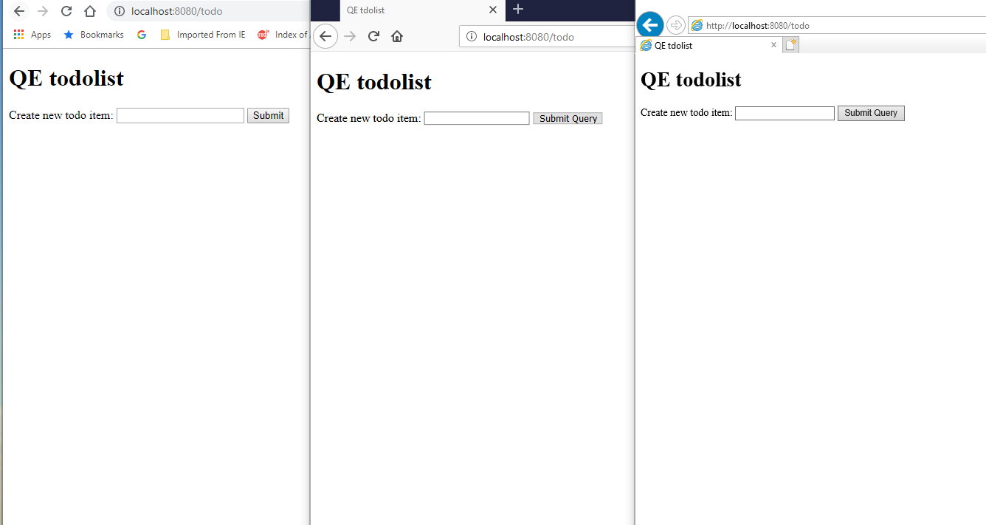

Test 4

Test 5

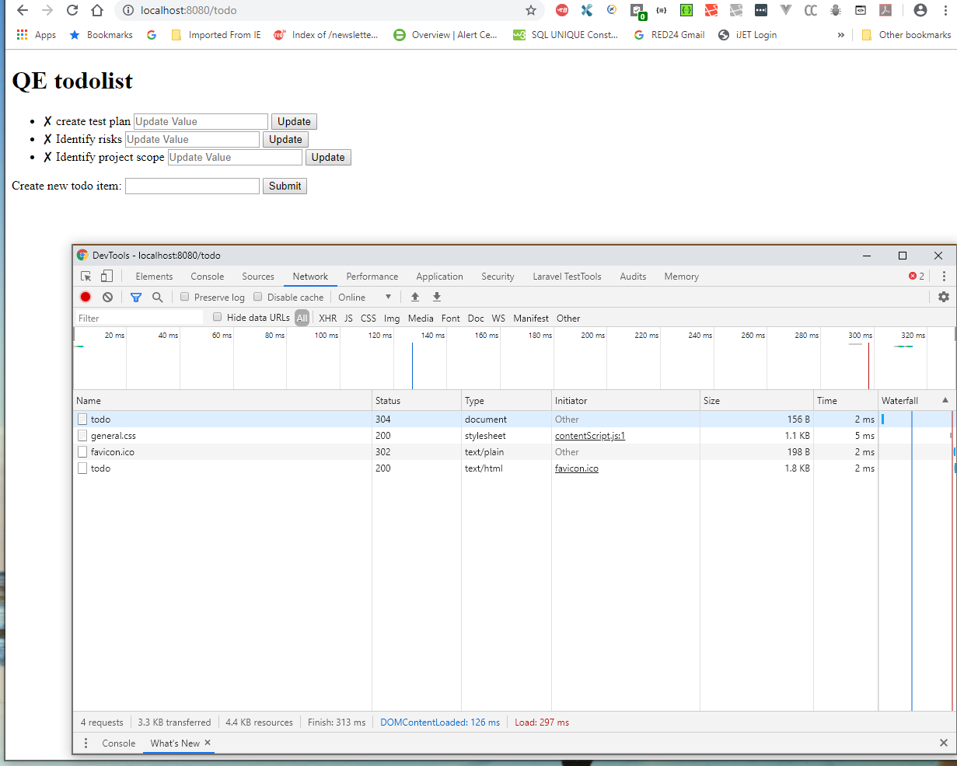

Test 6

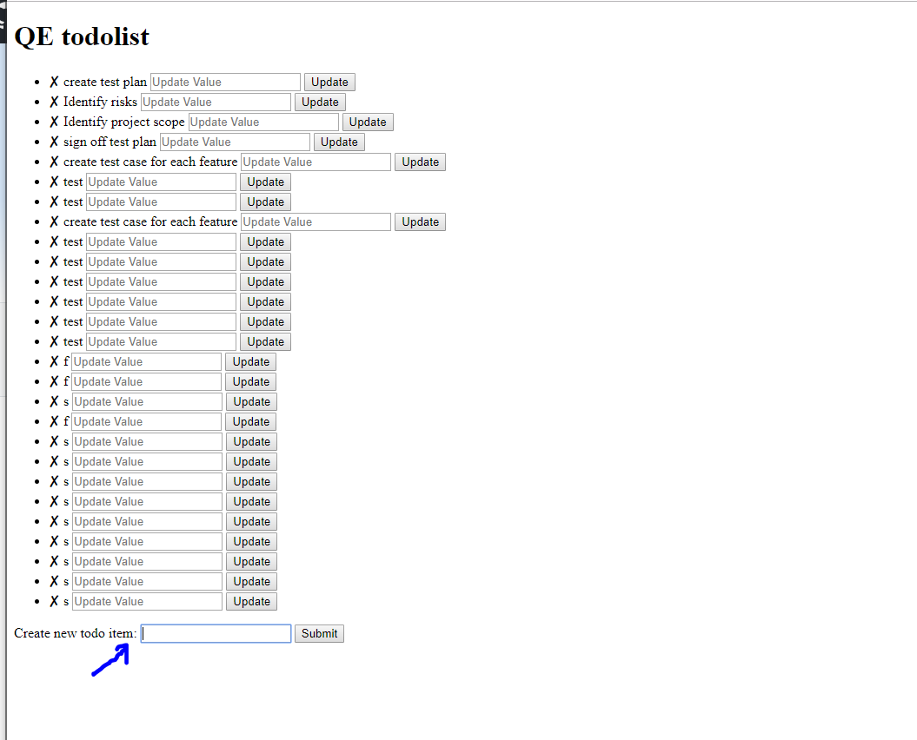

Test 7

